**Question – 2**

**a.**

The graph compares glucose data from a sample with the population. The sample mean (112) is less than the population mean (140), while the sample maximum (182) is much lower than the population maximum (200). This shows that the two datasets have different core tendencies and variability levels.

**b.**

The graph shows the 98th percentile of BMI (Body Mass Index) for a sample and the population. The sample's BMI percentile is roughly 37.5, but the population's is around 43.5, showing a significant discrepancy of nearly 6 BMI units. This indicates that the population has a larger proportion of people with higher BMIs. The difference emphasizes the need to use both sample and population data for assessing BMI figures.

**c.**

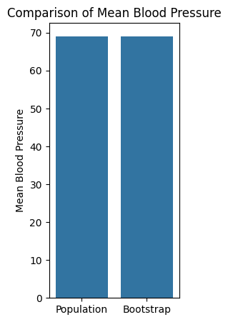

The graph compares the mean blood pressure in the population to a bootstrap sample. Both have a mean of around 66 mmHg, demonstrating that the bootstrap sample accurately represents the population. This shows that the bootstrap approach accurately represents the central tendency of the blood pressure distribution, increasing confidence in its dependability.

The graph shows that the standard deviation of blood pressure is significantly higher in the bootstrap group compared to the population. This indicates greater variability in blood pressure within the bootstrap sample, which may suggest the need for further investigation or targeted interventions.

The graph shows that the 75th percentile of blood pressure is slightly higher in the population (80.39 mmHg) compared to the bootstrap sample (80.19 mmHg). This suggests that the upper end of the blood pressure distribution in the population may be slightly elevated compared to the bootstrap sample.